**Ideation Phase**

**Define the Problem Statements**

| Date | 06 July 2024 |
| --- | --- |
| Team ID | SWTID1719923176 |
| Project Name | Project - Freelance Finder : Discovering Opportunities, Unlocking Potential. |
| Maximum Marks | 3 Marks |

**Customer Problem Statement:**

Freelancers face significant challenges in expanding their client base and finding diverse project opportunities due to the limitations of existing freelance job boards, which are often niche-specific or lack a wide range of options. This makes it difficult for freelancers to find varied opportunities that match their skills. Additionally, new freelancers struggle to determine appropriate rates for their services due to the absence of a centralized source providing reliable information on current market rates. This uncertainty about market rates and potential earnings adds to the difficulty, making it hard for new freelancers to set competitive yet fair pricing for their work. This situation results in freelancers feeling frustrated and uncertain, impacting their ability to grow and succeed in the competitive freelance market.

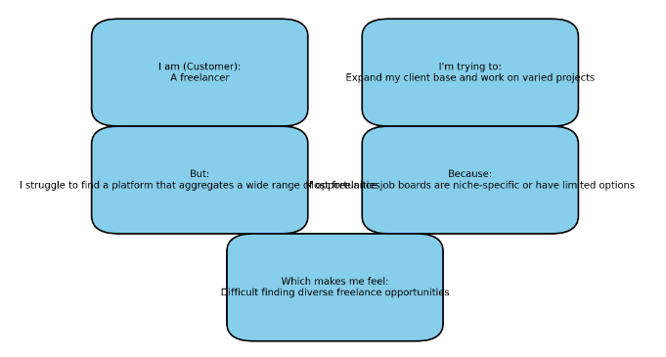

| **Problem Statement (PS)** | **I am (Customer)** | **I’m trying to** | **But** | **Because** | **Which makes me feel** |
| --- | --- | --- | --- | --- | --- |
| PS-1 | A freelancer | Expand my client base and work on varied projects | I struggle to find a platform that aggregates a wide range of opportunities | Most freelance job boards are niche-specific or have limited options | Difficult finding diverse freelance opportunities |
| PS-2 | A new freelancer | Understand what rates to charge for my services | I find it hard to get reliable information on current market rates | There is no centralized source of aggregated data on freelance earnings | Uncertain about market rates and potential earnings |